An example ageing criteria report

Pristipomoides zonatus

Eva Schemmel

Kristen Dahl

January 2023

Table of contents

# Citation

E Schemmel, 2024. Ageing Criteria Template. Pacific Islands Science Center.

# 1. Introduction

Pristipomoides zonatus is a deepwater snapper found in subtropical and tropical waters throughout the Indo-Pacific in rocky habitats from 70-300 meters (fishbase.org). The largest maximum length recorded is 57.7 cm (Kamikawa et al. 2015). P. zonatus is one of the deep water snappers in bottomfish fisheries in the central Pacific.

Otoliths are commonly used to estimate and in boney fishes. Growth can be assessed by counting the annual growth bands, with dark zones corresponding to slower growth during winter months and light zones corresponding to faster growth during summer months. However, growth can be variable and marks can appear on the otolith that may not correspond to annual marks (references). Therefore, ageing criteria and validation is warranted (Newman et al 2015). Age validation can be achieved in multiple ways such as using marginal increment analysis, edge analysis, and first increment analysis using daily growth increments (Newman et al 2017; O’Malley et al 2016). Additional validation can come from bomb radiocarbon dating (14C), and uses a reference signal of 14C created from thermonuclear testing in the 1950s and 1960s to estimate the age of individuals from material taken from the otolith core (Andrews et al 2012; Andrews 2016; Newman et al 2017).

Here we follow ageing criteria and validation methods have been developed for deepwater snappers (Newman et al. 2017; O’Malley et al 2016) to determine the feasibility of ageing P. zonatus. To develop ageing criteria, two readers examined X otoliths from Mariana Islands. We verified the location of the first annuali using daily counts. We then estimated the age precision (between-reader agreement, average percent error, and coefficient of variation). Prior work has been done for P. zonatus from Hawaii to estimate ages using bomb radiocarbon dating (Andrews 2019).

# 2. Methods

Each individual otolith is mounted and transversely sectioned, perpendicular to the sulcus acusticus using a Buhler Isomet Low Speed Saw, to a thickness that was species-specific and tested for annuli clarity. Otoltihs were sectioned to between 0.2 and 0.25 mm, dipped in 2.5.5 HCl solution, rinsed, and cover slipped.

Sectioned otoliths were examined using reflected light where dark opaque bands represent narrower and presumably slower growth bands and light translucent marks represent wider and presumably faster growth zones. Opaque bands were counted using a stereomicroscope, against a black background and under two obliquely reflecting light sources (one on each side of the microscope stage, at low angles), at 40-80x magnification. The opaque bands were counted across a consistent axis along the ventral portion of the section, from the primordium to the otolith margin.

#Identification of First Annual Mark Small otoliths that contained zero to one annuali were further processed for daily increment analysis to determine the location of the first annual mark. These otoliths were polished using progressively finer (30, 9, 3, 0.3 µm) lapping film until daily increments were clearly visible. Daily otolith increments were counted by one reader using an Olympus BX51compound microscope (magnification range 200–600×). Increments were counted from the core to each of the potential annual marks.

# 3. Edge Analysis

Growth increment periodicity was assessed using edge analysis. A simple edge type classification was used: 1 = opaque zone on the edge of the otolith section; 2 = translucent zone on the edge of the otolith section. The edge type was recorded for every otolith. A proportion of edge type was plotted for every month to validate increment periodicity (refer to Taylor and Cruz 2017).

# 4. Otolith Weight to Age Analysis

Otolith weight was compared to estimated ages and the coefficient of determination was calculated as a proxy of the accuracy of aging criteria following (Lou et al. 2005, Pilling et al. 2003; O’Malley et al. 2016).

# 5. Aging Criteria

Ageing criteria were developed with two readers by examining 100 thin (<0.25 mm) sectioned otoliths from the Mariana Islands. The two readers reviewed the otoliths and come to agreement on the location of the first annual mark prior to reading. The agers review the samples and image a subset of the reference set of otoliths to get a representative sample across the age range. The imaged reference set is used to calibrate the readers before each read. Blind readings of the sectioned otoliths were done by two readers.

Between reader agreement was assessed using the coefficient of variation and average percent error. The coefficient of variation (CV) is the ratio of the standard deviation over the mean (Chang, 1982). A mean CV was estimated by averaging the individual CV of all aged fish from Marina Island, and separately for all fish age from Hawaii. The average percent error (APE) was assessed from all aged fish in the Marianas Island sample and separately for all aged fish in the Hawaii sample. The index of average percent agreement (IAPE; Beamish and Fournier 1981) was determined by averaging the average percent error across all fish aged from Mariana Islands.

# 6. Results

A total of 48 otoliths were used in the reference collection and aged by two readers.

Identification of first annuli was attempted using DGI but counts were inconsistent.

|  |
| --- |
| Figure 6.1: P. zonatus section otolith with 2 annuali visible. |

## 6.1 Edge Analysis

## 6.2 Otolith Weight to Age Analysis

## 6.3 Ageing Criteria

Precision

n validn R PercAgree ASD ACV AAD APE  
 1315 48 2 43.75 0.604 12.25 0.4271 8.66  
-4 -3 -2 -1 0 1 2 3   
 2 0 8 27 44 10 2 6

symTest df chi.sq p  
1 McNemar 1 3.000000 0.08326452  
2 EvansHoenig 4 9.355556 0.05280138  
3 Bowker 13 19.500000 0.10839813

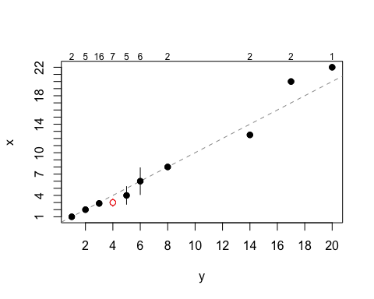{#fig-bias plot-1}

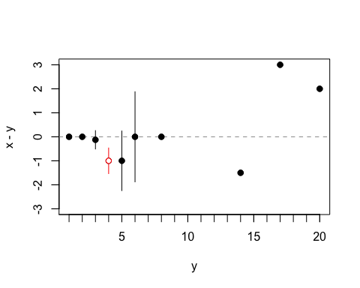{#fig-bias plot-2}

# 7. Discussion

# References